Arabic language and culture
Activity 1:
Activity 2:

Study the map of the Arab World and complete the table in English. Complete as many as you can

Name of Arab Country | Capital City

Activity 3:

Study the map of the Arab World and complete the table in English.

- Name one country that borders Iraq: _________________________________________________
- Name one country that borders Morocco: ____________________________________________
- Name one Arab country on the Atlantic Coast: _______________________________________
- Name one Arab country off the coast of Madagascar: ________________________________
- What are the two largest Arab countries: _____________________________________________
Activity 4:

The following people are of Arab origin. Can you remember the rest of their names?
 | 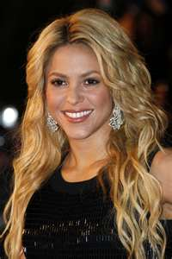 | 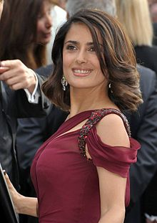 | 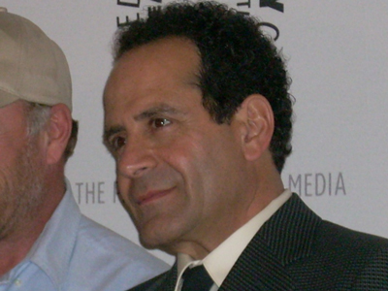
Steve _____________ | Sh___________ | Salma H________ | T_____ Shalhoub
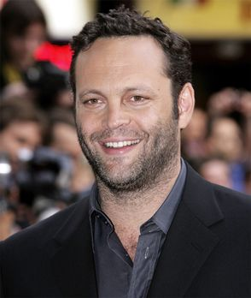 | 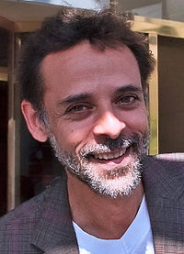 | 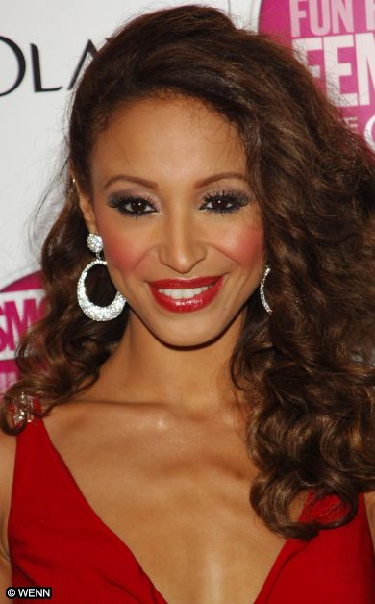 | 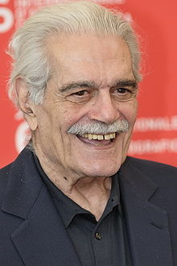
V__________ Vaughn | Ale_______ Siddiq | A_____ Berrabach | O________ Sharif

Activity 5:

Check the class display and ….

- Write two things about Queen Rania:___________________________________________________
- Write two things Princess Salma: _______________________________________________________
- Write two things about Ibn Sina: _______________________________________________________
- Write two things about Al Khawarizmi:________________________________________________
- Write two things about Omar Mokhtar:________________________________________________

